Information for Participants

6th APEC SEN Steering Council
and Expert Group Meeting

9-11 September
2024

Hybrid Meeting,
Busan, Republic of Korea

1. MEETING OBJECTIVES

APEC SEN is committed to addressing the evolving needs of the seafaring industry, while focusing on the challenges of ensuring a high degree of work-life balance for seafarers both onboard and onshore. In line with this, the 6th APEC SEN Steering Council and Expert Group Meeting aim to explore essential topics such as maritime education and training, seafarers’ better welfare, career development and job transitions, as well as long-term plans for APEC SEN under the APEC framework. It will also serve as a venue for seafarers' policymakers to exchange ideas and visions to address the current issues at hand.

2. EVENT DATE
9-11 September 2024 (Please also refer to the ANNEX I)

3. VENUE

The meeting will be conducted in a hybrid format, offering both in-person and virtual attendance options (The online meeting link will be provided for the registered participants in the future).

Detailed address for the offline participants:
La Valse Hotel, 82, Bongnaenaru-ro, Yeongdo-gu, Busan, The Republic of Korea
https://www.lavalsehotel.com (+82-51-790-1500)

Offline participating delegates are encouraged to arrange their own airport transfer to the venue. Transfer from the airport to the venue will take approximately 1 hour (depending on traffic).

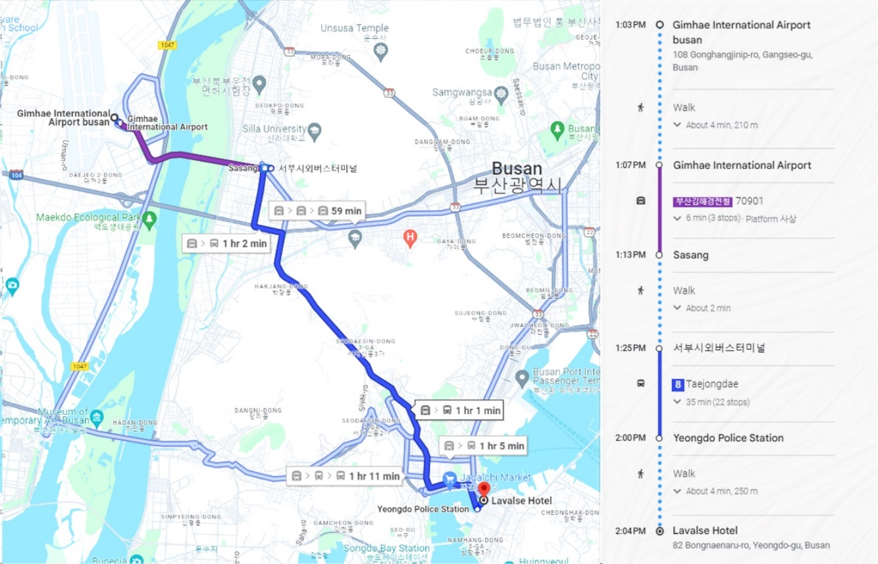
< Using Public Transportation >

For your convenience, the following transportation options are available from the Gimhae Airport to the venue:

1. Taxi
There is a taxi rank directly as you exit the terminal. You can expect to pay KRW 30,000 each way. It is approximately a one-hour trip.

2. Public Transportation
(Subway) Airport Station (Busan-Gimhae Line) → Sasang Station → (Transfer to Bus) Busan Seobu Intercity Bus Terminal → Youngdo Police Station → Five minutes’ walk to Lavalse Hotel. The fare is KRW 2,000 and it is approximately a one-hour and twenty-minute trip.

4. HOTEL INFORMATION

The designated hotel is the same as the meeting venue, the Lavalse Hotel. For general information, please refer to the same link provided in the meeting venue:
https://www.lavalsehotel.com (+82-51-790-1500)

(4.1) Room Rates

Room Type | Floor | Regular Rate | Discount Rate
 |  |  | Non-Corporate  Affiliated Rate | Corporate  Affiliated Rate
Standard City | 5-17F | ₩ 400,000 | ₩ 140,000 | ₩ 110,000
Standard Ocean | 6-21F | ₩ 600,000 | ₩ 160,000 | ₩ 130,000
Deluxe Ocean | 18-27F | ₩ 726,000 | ₩ 190,000 | ₩ 160,000
Ondol | 13-16F | ₩ 848,000 | ₩ 220,000 | ₩ 190,000
Triple | 11-27F | ₩ 848,000 | ₩ 220,000 | ₩ 190,000
Corner Ocean | 5-22F | ₩ 880,000 | ₩ 250,000 | ₩ 210,000

* All prices are inclusive of tax but do not include breakfast

(4.2) Reservation Method

To register for a corporate-affiliated room through our secretariat, please send your intention to stay, along with your name, dates of stay, and contact information by August 15th. Payments can be made directly to the hotel upon arrival.

5. PARTICIPANTS

All 21 APEC member economies are welcome and invited to attend and actively participate in the Steering Council and Expert Group Meetings.

Nominations for this event are being sought from APEC Transportation Working Group, Maritime Expert Group, and seafaring-related government officers of each APEC economy, and experts from the maritime industry or academia.

Both online and offline participants are required to fill out the forms in the provided link. https://forms.gle/TjuJQNyJ4eBZ2H5m8

* For offline participants, please check the K-ETA requirements below before traveling to Korea.

K-ETA (Korea Electronic Travel Authorization) is required for visa-free entry to South Korea. Applications should be made in advance as processing can take over 72 hours. Approved K-ETA is valid for multiple entries over three years, but does not guarantee entry, which is decided by immigration officials. For more details, visit K-ETA Application Guide (https://www.k-eta.go.kr/portal/apply/index.do).

6. AGENDA

The tentative agenda of the meeting is attached as ANNEX I, which is subject to change.

7. METHODOLOGY

(6.1) Organization of Program

Target audiences of this project are:
Members from the APEC TPTWG, MEG, and the APEC SEN Steering Council and Expert Groups are invited. Furthermore, in our pursuit of inclusivity and diversity, we especially encourage nominations of qualified experts from maritime administrations of member economies who are keen on seafarers’ issues including maritime education and training, seafarer’s welfare, career development and their job transition. We also strongly urge economies to consider nominating qualified female participants.

(6.2) Language

The workshop will be conducted in English.

8. INSTITUTION

The meeting will be organized by APEC Seafarer’s Excellence Network. For meeting information, please contact the points listed below.

Mr. Jin Ki Seor
APEC SEN, Director, Email: secretariat@apec-sen.org

9. MISCELLANEOUS

All attendees need to ensure while drafting any workshop documents or making presentations at the meeting to please be mindful of APEC nomenclature. APEC is a grouping of economies. Therefore, it is inappropriate to use anything, such as flags or emblems, which may imply the “political status” of any member economy. Disputed maps should not be included in any presentations or materials distributed at an APEC event. Members of APEC should be referred to as “member economies” or “members” or “economies”. Please do not use in reference to APEC member economies the words “country”, “nation” or “national”.

Please also be mindful to use the correct names of the APEC economies: Australia; Brunei Darussalam; Canada; Chile; the People's Republic of China (China also acceptable); Hong Kong, China; Indonesia; Japan; the Republic of Korea; Malaysia; Mexico; New Zealand; Papua New Guinea; Peru; the Republic of the Philippines (the Philippines also acceptable); the Russian Federation (Russia also acceptable); Singapore; Chinese Taipei; Thailand; the United States of America (the USA, the US or the United States also acceptable); Viet Nam.

10. PRACTICAL INFORMATION

Time Zone: UTC+9 hours

Banks & Currency: The unit of Korean currency is Korean Won (KRW). The exchange rate as of July 2024 is KRW 1,381 to 1 USD. Automated teller machines (ATM) are widely accessible throughout the Republic of Korea.

Electricity:

 | Supply voltage is 220V, 60Hz. Please ensure you bring the correct adapter for your equipment.

Emergencies: Police 112, Fire Department 119, Medical Emergencies 1339

Economy | Display Name
AUSTRALIA | 02 AUS/FULL NAME
BRUNEI DARUSSALAM | 03 BD/FULL NAME
CANADA | 04 CDA/FULL NAME
CHILE | 05 CHL/FULL NAME
PEOPLE’S REPUBLIC OF CHINA | 06 PRC/FULL NAME
HONG KONG, CHINA | 07 HKC/FULL NAME
INDONESIA | 08 INA/FULL NAME
JAPAN | 09 JPN/FULL NAME
REPUBLIC OF KOREA | 10 ROK/FULL NAME
MALAYSIA | 11 MAS/FULL NAME
MEXICO | 12 MEX/FULL NAME
NEW ZEALAND | 13 NZ/FULL NAME
PAPUA NEW GUINEA | 14 PNG/FULL NAME
PERU | 15 PE/FULL NAME
THE PHILIPPINES | 16 PHL/FULL NAME
THE RUSSIAN FEDERATION | 17 RUS/FULL NAME
SINGAPORE | 18 SGP/FULL NAME
CHINESE TAIPEI | 19 CT/FULL NAME
THAILAND | 20 THA/FULL NAME
UNITED STATES | 21 US/FULL NAME
VIET NAM | 22 VN/FULL NAME
APEC SECRETARIAT | 23 APECSEC/FULL NAME
PRIVATE SECTOR REPRESENTATIVE | FULL NAME/ORGANISATION/ECONOMY
GUEST (Inc. NMPs) | GUEST/FULL NAME/ORGANISATION
11. USERNAMES AND DISPLAY SETTINGS (FOR ONLINE PARTICIPANTS)
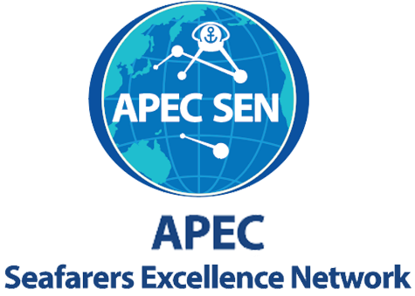
Participants are encouraged to use the following format for the display name:
ANNEX I

Agenda
APEC SEN Steering Council Meeting
Date | Time (SGT) | Item | Topics
09.09 | 7:30 – 8:00 | - | Members login
 | 8:00 – 8:10 | 1. | Opening Session  - Welcoming Remarks from APEC SEN Secretary General  - Mr. Min Jong KIM, APEC SEN Secretary General  - Remarks from the Lead Shepherd of TPTWG  - Mr. Beasung KIM, TPTWG Lead Shepherd
 | 8:10 – 9:40 | 2. | Opening of Steering Council (SC) Meeting  - Opening Remarks from the Chair of APEC SEN SC  - Adoption of the Agenda  - Brief on APEC SEN Updates (ToR, Workshop) by APEC SEN Secretariat  - Agenda of the Expert Group Meetings  - Expert Group Organizational Framework Review  - Consideration on Strategic Plan for the SEN for the four-year period 2025 to 2028  - Mr. Sok-Hun KIM, the Chair of APEC SEN SC
 | 9:40 – 9:45 | 3. | Photo Session (Virtual & In-Person)
 | 9:45 – 10:00 | - | Break Time
 | 10:00 – 11:30 | 4. | Expert Group 3 on Navigation Technology and High-quality Development of Seafarer
 | 11:30 – 13:00 | - | Lunch Break
 | 13:00 – 14:00 | 5. | (For offline Participants) Discussions on the APEC SEN Current and Future Activities
 | 14:00 – 17:00 | 6. | (For offline Participants) Technical Tour at KIMFT Training Ship
 | 17:00 – 20:00 | - | Networking Dinner
09.10 | 8:00 – 9:15 | 7. | Expert Group 1 on Challenges of Maritime Education and Training with New Emerging Standards and Technologies
 | 9:15 – 9:45 | - | Break Time
 | 9:45 – 11:00 | 8. | Expert Group 1 on Activity Reports and Future Plan
 | 11:00 – 13:00 | - | Lunch Break
 | 13:00 – 14:00 | 9. | (For offline Participants) Discussions on Project Engagement within APEC TPTWG/MEG
 | 14:00 – 17:00 | 10. | (For offline Participants) Technical Tour at KIMFT
 | 17:00 – 20:00 | - | Farewell Dinner
09.11 | 8:00 – 9:45 | 11. | Expert Group 2 on Advancing Job Appeal for Asia-Pacific Seafarers: Safeguarding Rights and Enhancing Welfare
 | 9:45 – 10:15 | - | Break Time
 | 10:15 -11:30 | 12. | Closing of Steering Council Meeting  - Summary of each Expert Group Meetings by its Chair  - Selection of APEC SEN Chairs and Vice Chairs for Next Term (2025-2026)  - Information on 2025 Work Plan by the Secretariat  - Mr. Sok-Hun KIM, the Chair of APEC SEN SC
 | 11:30 – 13:00 | - | Lunch Break
 | 13:00 – 17:00 | - | Technical Tour (Optional)

Agenda
Expert Group 1 Meeting
8:00 – 11:00 10 September 2024 Hybrid Meeting

Date | Time (SGT) | Item | Topics :  Challenges of Maritime Education and Training  with New Emerging Standards and Technologies
09.10 | 8:00 – 8:20 | 1. | Opening Remark for Expert Group 1  - Overview of Expert Group 1 Agenda  - Prof. Jin-soo PARK, Professor, Korea Institute of Maritime and Fisheries Technology
 | 8:20 – 8:40 | 2. | Keynote speaker  - Development Direction and Tasks of the STCW Convention for Fair Transition and Sustainable Training of Maritime Human Resource  - Prof. Hyun Wook DOO, Professor, Korea Institute of Maritime and Fisheries Technology
 | 8:40 – 9:00 | 3. | Agenda 1  - Concerns in Seafarer Education from Recent Change and Challenges in Seafarer Employment  - Prof. Zhengrong SHA, Professor, Guangzhou Maritime University
 | 9:00 – 9:15 | 4. | Agenda 2  - Korean ODA Capacity Building Program for Seafarers  - Mr. Chan KIM, Instructor, Korea Institute of Maritime and Fisheries Technology
 | 9:15 – 9:45 | - | -Break Time-
 |  |  | EG1: Activity Reports and Future Plans
 | 9:45 – 10:00 | 5. | Agenda 3  - Outcomes of the APEC SEN Workshop on Maritime Transportation Workforce: (Part 1)  - Ms. Ye Rim PYO, Project Overseer, APEC SEN Secretariat
 | 10:00 – 10:50 | 6. | Agenda 4  - Expert Group 1 Updates and Future Workplan  - Dr. Jin-soo PARK, Professor, Korea Institute of Maritime and Fisheries Technology
 | 10:50 – 11:00 | 7. | Agenda 5  - Q&A Discussions, Closing

Agenda
Expert Group 2 Meeting
8:00 – 9:45 11 September 2024 Hybrid Meeting

Date | Time (SGT) | Item | Topic :  Advancing Job Appeal for Asia-Pacific Seafarers:  Safeguarding Rights and Enhancing Welfare
09.11 | 8:00 – 8:10 | 1. | Opening Remark for Expert Group 2  - Overview of Expert Group 2 Agenda  - Ms. Presca Lee B. LUGO, MET Standards Supervisor, MARINA- STCW Office
 | 8:10 – 8:30 | 2. | Agenda 1  - Case Studies: Ambulance Chasing in the Philippines  - Atty. Henry S. ZAMORA, Associated Marine Officers' and Seamen's Union of the Philippines (AMOSUP)
 | 8:30 – 8:50 | 3. | Agenda 2  - Outcomes: Study on the Maritime Transport Sector in the COVID-19 Era: Challenges, Opportunities, and the Way Forward  - Dr. Khanssa LAGDAMI, ITF Seafarers Trust Associate Professor of Maritime Labour Law & Policy, World Maritime University
 | 8:50 – 9:10 | 4. | Agenda 3  - Advancements in Maritime Labour Rights and Seafarers' Wellbeing: Insights from the Malaysia Maritime Labour Rights Forum 2024  - Mr. Mohd Nurrul FAIZ, Senior Marine Officer, Marine Department Malaysia
 | 9:10 – 9:20 | 5. | Agenda 4  - Outcomes of the APEC SEN Workshop on Maritime Transportation Workforce: (Part 2) Women in Maritime Capacity Building Initiatives  - Ms. Ye Rim PYO, Project Overseer, APEC SEN Secretariat
 | 9:20 – 9:30 | 6. | Agenda 5  - Expert Group 2 Updates and Future Workplan  - Chair of APEC SEN EG 2
 | 9:30 – 9:45 | 7. | Agenda 6  - Q&A Discussions, Closing

Agenda
Expert Group 3 Meeting
10:00 – 11:30 9 September 2024 Hybrid Meeting

Date | Time (SGT) | Item | Topic :  Navigation Technology and High-quality Development of Seafarer
09.09 | 10:00 – 10:10 | 1. | Chair’s Remark for Expert Group 3  - Overview of Expert Group 3 Agenda  - Prof. Xiu Ying BI, Vice President, Guangzhou Maritime University
 | 10:10 – 10:25 | 2. | Keynote speaker  - STCW Implications for High-Quality Skill Development of Marine Engineers  - Prof. Redzuan Zoolfakar MD, Director, University Kuala Lumpur Centre for Industrial Linkages
 | 10:25 – 10:45 | 3. | Agenda 1  - Future Seafarer's Skills and Education for the Autonomous Vessels  - Dr. Barkasov MAXIM, Lead Expert, MARINET RUT
 | 10:45 – 11:05 | 4. | Agenda 2  - Essential Navigation Skills for Current Officers Onboard  - Prof. Xiu Ying BI, Vice President, Guangzhou Maritime University
 | 11:05 – 11:15 | 5. | Agenda 3  - EG3 Updates and Future Workplan  - Chair of APEC SEN EG3
 | 11:15 – 11:30 | 6. | Agenda 4  - Q&A Discussions, Closing

ANNEX II
NOMINATION FORM
APEC SEN Steering Council and Expert Group Meeting

* The registration can also be completed through https://forms.gle/TjuJQNyJ4eBZ2H5m8

Complete all fields and return to Nominations Focal Point below:
[APEC SEN Secretariat, secretariat@apec-sen.org, +82 51-620-5775]

By completing and returning this form, I consent to the collection, use and disclosure of the personal data provided below to the APEC Secretariat, for the purposes of project administration and evaluation and to be handled in accordance with the APEC Secretariat Personal Data Protection Policy.

APEC MEMBER ECONOMY: [INSERT]
NOMINEE 1
Name (CAPITALISE surname): [INSERT]
Title (Dr/Mr/Ms/Mrs): [INSERT] Position:
Gender (M/F): [INSERT]
Organization: [INSERT] Email: [INSERT]
Telephone: [INSERT] Fax: [INSERT]
Nominated as an Expert Speaker: Yes / No APEC-funded / Self-funded
Nominated as an Active Participant: Yes / No APEC-funded / Self-funded
Government official: Yes / No
NOMINEE 2
Name (CAPITALISE surname): [INSERT]
Title (Dr/Mr/Ms/Mrs): [INSERT] Position:
Gender (M/F): [INSERT]
Organization: [INSERT] Email: [INSERT]
Telephone: [INSERT] Fax: [INSERT]
Nominated as an Expert Speaker: Yes / No APEC-funded / Self-funded
Nominated as an Active Participant: Yes / No APEC-funded / Self-funded
Government official: Yes / No

Name of official making the above Nomination(s):
Economy Representative for which APEC Fora:
Title:
Organization:
Email:
Telephone:
Fax:

